News: August 17, 2016–for Immediate Release
Re: South Suburban College, www.ssc.edu
Contact: Public Relations (708) 596-2000, ext. 2463

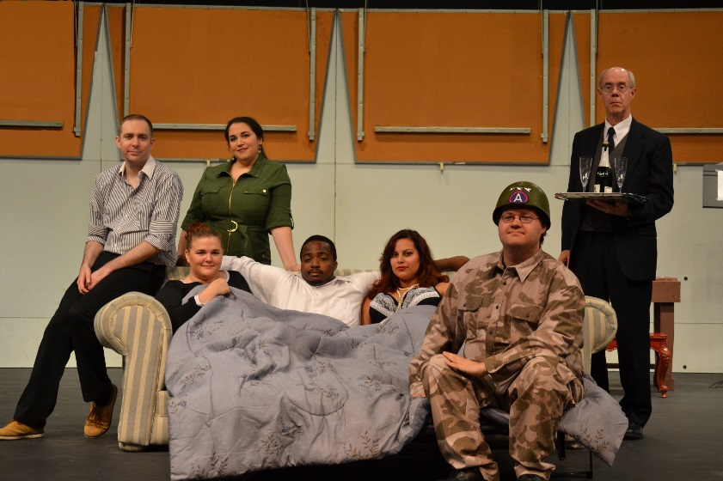

Pictured: The cast of “The Amorous Ambassador”

The “Amorous Ambassador” is Slapstick Silliness at South Suburban College

SOUTH HOLLAND - The PAC Rats Theatre Company of South Suburban College will present Michael Parker’s randy romp, The Amorous Ambassador. Performances will take place in the Kindig Performing Arts Center on the main campus on September 16, 17 and 23 at 8pm, September 24 at 2pm and 8pm and September 25 at 2:00 p.m.

In the tradition of true British bedroom farce, Parker weaves a web of circumstance laced with quick exits and entrances, visual humor and clever one-liners.

Perkins (Pat Nevins of Homewood), a very dignified English butler, exercises extreme discretion as each of the members of the Douglas family confide their weekend plans. They each plot to have the U.S. Ambassador to Great Britain’s estate to themselves for a romantic rendezvous. Harry (Julian Hall of South Holland) announces that he will be playing golf in Scotland, while his wife Lois (Diamond Sanders of Sauk Village) and daughter Debbie (Catherine Hundt of Thornton) mention plans of their own.

Thinking the house is empty, they each arrive back at the estate with their paramour. Their predicament is further complicated when a bomb threat sends Harry’s secretary, Faye (Amy Pniewski of Thornton), and Marine Captain South (Kevin Hathaway of Park Forest) to fulfill security measures. The cast is completed by Harry’s sexy neighbor and current lover, Marian (Ashley Orendorff of Thornton) and Debbie’s boyfriend, Joe (Charlie Furtek of Lansing).

The play is directed by Midlothian resident Angela Martin. Set design is by Dean Scalzitti of Hegewisch. The costume designer is Joanna Tassin of Park Forest. Sandra Wagner is the stage manager and Laura Tiemens is the lighting designer. Both are from Lansing. Heather Young of Chicago is designing the props for the production and Jordan Swierczyna of Robbins is the sound designer.

Tickets are just $8 for adults, $6 for seniors 55 or better, $6 for students. South Suburban College staff and students will enjoy a buy one, get one offer with an I.D. Call the 24/7 box office voicemail line at 708-210-5741. You may also reserve tickets by e-mail at boxoffice@ssc.edu. Group rates are also available. Playwright Michael Parker will make himself available for phone interviews. Email: michaelsusanparker@yahoo.com

South Suburban College is located at 15800 S. State Street in South Holland, Illinois, between Sibley Boulevard and 159th Street. The campus is convenient to Routes 94, 80, 57, and 294. Free, ample, well-lit parking is available.

####

